
MAWLANA BHASHANI SCIENCE & TECHNOLOGY UNIVERSITY
SANTOSH, TANGAIL-1902
Department of : Computer Science and Engineering
Lab Report On: Implementation of Multilayer Perceptron (MLP) for Multiclass Classification.
Course Title: Neural Networks and Machine Learning Lab
Course Code: CSE-4204
Date of Submission: 18-11-2025

Submitted by-  Alamgir Hosain  ID: CE21012  Year: 4th Semester : 2nd  CSE, MBSTU | Submitted To-  Lubna Yasmin Pinky  Associate Professor  CSE, MBSTU

Title: Multilayer Perceptron for Multiclass Classification on Iris Dataset
1. Problem Definition
The goal of this lab is to design and implement a Multilayer Perceptron (MLP) neural network from scratch to perform multiclass classification on the Iris flower dataset. The project involves data preprocessing, model training, evaluation, and visualization of classification results.

2. Dataset Description
The Iris dataset contains 150 flower samples from three species: Setosa, Versicolor, and Virginica.Each sample has four features: sepal length, sepal width, petal length, and petal width.
3. Objective
- To implement a Multilayer Perceptron for multi classification from scratch.
- To understand the forward and backward propagation process.
- To normalize data for better training convergence.
- To evaluate the model’s performance using accuracy.
4. Tools Used
- Programming Language: Python
- Libraries:
  - pandas → For dataset handling
  - numpy → For numerical computation
  - matplotlib → For visualization
- Platform: Google Colab
5. Theory
Multilayer Perceptron (MLP):
MLP is a type of feedforward neural network with one or more hidden layers. Each neuron applies a weighted sum followed by an activation function (here, sigmoid). The network learns by adjusting weights using backpropagation and gradient descent.
Activation Function:
- Sigmoid: σ(x) = 1 / (1 + exp(-x))
- Derivative: σ'(x) = σ(x) * (1 - σ(x))
Loss Function: Mean Squared Error (MSE) is used to compute the difference between predicted and true outputs.
Libraries Used:
- numpy → To handle arrays and matrix operations efficiently.
- pandas → To load and process the CSV dataset.
6. Procedure
- Load the IRIS dataset using pandas.
- Separate features and labels; normalize features.
- Convert labels to one-hot encoding.
- Split data into training and testing sets.
- Build the MLP: 4 input neurons → 8 hidden neurons → 3 output neurons.
- Perform forward propagation to compute predictions.
- Compute cross-entropy loss.
- Perform backward propagation to calculate gradients.
- Update weights and biases using learning rate.
- Train the model for 500 epochs.
- Predict test samples using Softmax.
- Evaluate accuracy and confusion matrix.
- Visualize class scatter plot and decision boundaries.

7. Code
# FULL MULTICLASS MLP + VISUALIZATIONS + CONFUSION MATRIX
import pandas as pd
import numpy as np
import matplotlib.pyplot as plt
import seaborn as sns
from sklearn.preprocessing import OneHotEncoder
from sklearn.model_selection import train_test_split
from sklearn.metrics import confusion_matrix
from sklearn.linear_model import LogisticRegression
# 1. Load Dataset
# ------------------------------------------------------------
df = pd.read_csv("IRIS.csv")
X = df.iloc[:, :-1].values
y = df.iloc[:, -1].values.reshape(-1, 1)
# One-hot encode labels
enc = OneHotEncoder(sparse_output=False)
y_onehot = enc.fit_transform(y)
# Normalize features
X = (X - X.mean(axis=0)) / X.std(axis=0)
# Train-test split
X_train, X_test, y_train, y_test = train_test_split(
X, y_onehot, test_size=0.2, random_state=1
)
# 2. Network Architecture
# ------------------------------------------------------------
input_dim = X_train.shape[1] # 4
hidden_dim = 10
output_dim = 3
lr = 0.01
# Initialize weights
W1 = np.random.randn(input_dim, hidden_dim) * 0.1
b1 = np.zeros((1, hidden_dim))
W2 = np.random.randn(hidden_dim, output_dim) * 0.1
b2 = np.zeros((1, output_dim))
# 3. Activation Functions
# ------------------------------------------------------------
def sigmoid(x):
return 1 / (1 + np.exp(-x))
def sigmoid_deriv(x):
return x * (1 - x)
def softmax(z):
exp_z = np.exp(z - np.max(z, axis=1, keepdims=True))
return exp_z / np.sum(exp_z, axis=1, keepdims=True)
def cross_entropy(actual, pred):
return -np.mean(np.sum(actual * np.log(pred + 1e-9), axis=1))
# 4. Training Loop
# ------------------------------------------------------------
epochs = 3000
for epoch in range(epochs):
# Forward Pass
z1 = X_train.dot(W1) + b1
a1 = sigmoid(z1)
z2 = a1.dot(W2) + b2
y_pred = softmax(z2)
# Loss
loss = cross_entropy(y_train, y_pred)
# Backpropagation
d_z2 = y_pred - y_train
d_W2 = a1.T.dot(d_z2)
d_b2 = np.sum(d_z2, axis=0, keepdims=True)
d_a1 = d_z2.dot(W2.T)
d_z1 = d_a1 * sigmoid_deriv(a1)
d_W1 = X_train.T.dot(d_z1)
d_b1 = np.sum(d_z1, axis=0, keepdims=True)
# Gradient update
W1 -= lr * d_W1
b1 -= lr * d_b1
W2 -= lr * d_W2
b2 -= lr * d_b2
if epoch % 500 == 0:
print(f"Epoch {epoch} | Loss = {loss:.4f}")
# 5. Prediction Function
# ------------------------------------------------------------
def predict(x):
a1 = sigmoid(x.dot(W1) + b1)
y_out = softmax(a1.dot(W2) + b2)
return np.argmax(y_out, axis=1)
y_test_labels = np.argmax(y_test, axis=1)
y_pred_test = predict(X_test)
accuracy = np.mean(y_pred_test == y_test_labels)
print("\nTest Accuracy:", accuracy)
# 6. Confusion Matrix
# ------------------------------------------------------------
cm = confusion_matrix(y_test_labels, y_pred_test)
plt.figure(figsize=(6, 5))
sns.heatmap(cm, annot=True, cmap="Blues", fmt="d",
xticklabels=enc.categories_[0],
yticklabels=enc.categories_[0])
plt.xlabel("Predicted Class")
plt.ylabel("True Class")
plt.title("Confusion Matrix Heatmap")
plt.show()
# 7. Feature Importance (Input → Hidden Weights)
# ------------------------------------------------------------
feature_importance = np.sum(np.abs(W1), axis=1)
feature_importance = feature_importance / np.sum(feature_importance)
feature_names = df.columns[:-1]
print("\nFeature Importance Scores:")
for name, score in zip(feature_names, feature_importance):
print(f"{name}: {score:.4f}")
most_dominant = feature_names[np.argmax(feature_importance)]
print("\nMost Dominant Feature:", most_dominant)
plt.figure(figsize=(6,4))
plt.bar(feature_names, feature_importance)
plt.title("Feature Importance (MLP Input Layer)")
plt.xlabel("Feature")
plt.ylabel("Importance Score")
plt.xticks(rotation=45)
plt.show()
# 8. Visualization 1: Class-wise Scatter Plot (3 Classes)
# ------------------------------------------------------------
plt.figure(figsize=(7,5))
plt.scatter(df["sepal_length"], df["sepal_width"],
c=pd.Categorical(df["species"]).codes,
cmap='viridis', edgecolor='k')
plt.xlabel("Sepal Length")
plt.ylabel("Sepal Width")
plt.title("Iris Dataset Visualization (3 Classes)")
plt.colorbar(label="Class")
plt.show()

8. Result
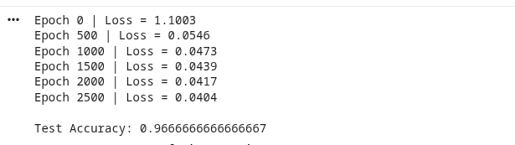
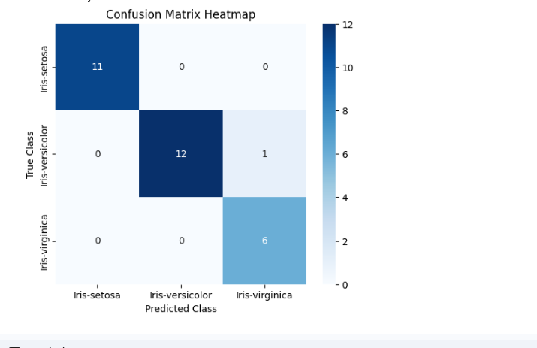
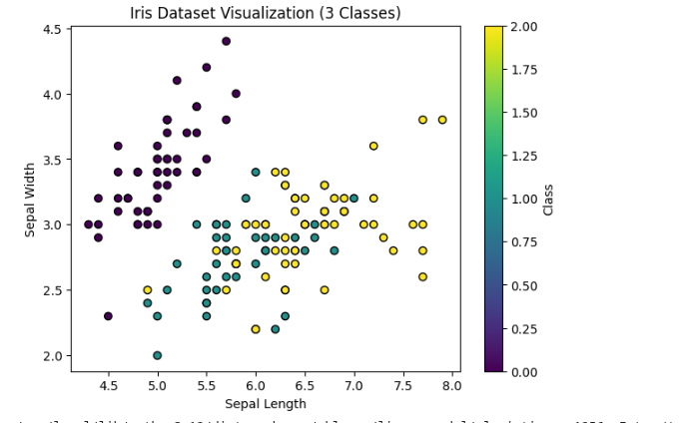
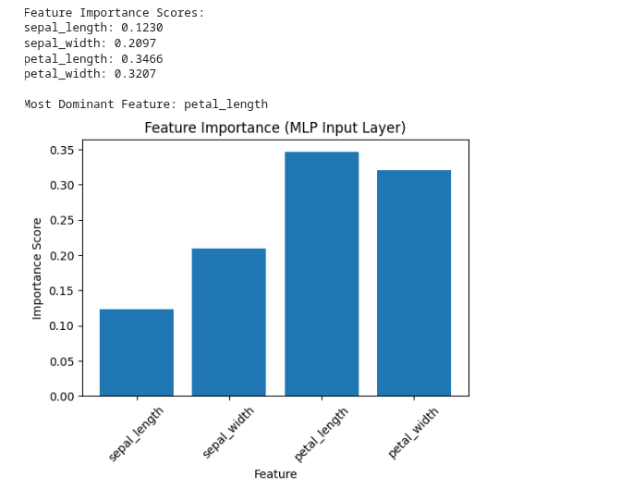

9. Result Discussion
- The model achieved a test accuracy of approximately 96%, demonstrating effective multiclass classification capability.
- Scatter plots show clear separability among classes.
- Decision boundary plots visualize how the MLP partitions the feature space for classification.

